North East Texas Regional Mobility Authority
Title VI Nondiscrimination Plan

Table of Contents
I. Introduction 1
II. Discrimination under Title VI 2
III. Authorities 3
IV. Title VI/ Nondiscrimination Policy Statement 4
V. Title VI/Title VI Nondiscrimination Assurances 5
VI. Title VI Coordinator/Organization and Staffing 6
VII. Primary Program Area Descriptions & Review Procedures 7
VIII. Data Collection and analysis 9
IX. Notice to the Public 10
X. Title VI Complaint Handling 11
XI. Complaint Procedures 11
XII. Title VI Investigations, Complaints, and Lawsuits 12
XIII. Public Participation Process 13
XIV. Accommodations for Limited English Proficient (LEP) Persons 15
A. LEP Plan 15
B. Meaningful Access: Four Factor Analysis 15
C. Vital Documents 16
D. Language Assistance 16
E. Language Assistance Measures 17
F. Staff Training 17
G. Translation of Documents 17
H. Monitoring and Updating the LEP Plan 17
I. Dissemination of the NET RMA LEP Plan 18
XV. Solicitation for bid/request for proposal 20
XVI. Title VI Contract Provisions 21
XVII. Training 22
Attachments

Attachment A – Signed non-discrimination agreement (English)
Attachment B – Signed non-discrimination agreement (Spanish)
Attachment C – NET RMA Organization Chart
Attachment D – Title VI Assurances
Attachment E – Title VI Contractor Provisions (Appendix A to Title VI Assurances)
Attachment F – Clauses for Deeds Transferring United States Property (Appendix B to Title VI Assurances)
Attachment G – Clauses for Transfer or Real Property Acquired or Improved Under the Activity, Facility or Program (Appendix C to Title VI Assurances)
Attachment H – Clauses for Construction/Use/Access to Real Property Acquired Under the Activity, Facility or Program (Appendix D to Title VI Assurances)
Attachment I – Additional Clauses (Appendix E to Title VI Assurances)
Attachment J – Title VI Complaint Procedures
Attachment K – Title VI Complaint Form (English)
Attachment L – Title VI Compliant Form (Spanish)
Attachment M – “I Speak” Language Identification Card
Attachment N – FHWA Form-1273
Attachment O – Sample Public Involvement Plan

Introduction

Title VI of the Civil Rights Act of 1964 prohibits discrimination on the basis of race, color, or national origin in any program or activity receiving federal financial assistance. Several other federal legal authorities supplement Title VI by extending protections based on age, sex, and disability. In addition, the Civil Rights Restoration Act of 1987 clarified Title VI enforcement by mandating that Title VI requirements apply to all programs and activities of federal-aid recipients regardless of whether any particular program or activity involves federal funds. Taken together, these laws require recipients and subrecipients of federal funds to ensure all programs and services are delivered to the public without discrimination. NET RMA, as a subrecipient of federal financial assistance, will ensure full compliance with Title VI of the Civil Rights Act of 1964; 49 C.F.R. Part 21 (Department of Transportation Regulations for the Implementation of Title VI of the Civil Rights Act of 1964); 49 C.F.R. Part 21; and related statutes and regulations. NET RMA acknowledges it is subject to and will comply with Federal Highway Administration Title VI Assurances.

This plan explains how NET RMA incorporates the requirements of Title VI and related legal authorities into its operations and includes the implementation procedures, strategies, and activities to facilitate and assure nondiscrimination. The plan will be used as a reference for NET RMA and as an informational resource for the public. This plan will be reviewed and updated every three years to reflect changes in Title VI compliance operations and will remain available to the public on the NET RMA’s website, https://www.netrma.org/net-rma-policies/title-vi-program/.

Discrimination under Title VI

It is the responsibility of every NET RMA employee to prevent, minimize, and eradicate any form of discrimination. There are two types of discrimination prohibited under Title VI and its related statutes: (1) disparate treatment that alleges similarly situated persons are treated differently because of their race, color, or national origin (i.e., intentional discrimination); and (2) disparate impact/effects when a facially neutral policy, procedure, or practice results in different or inferior services or benefits to members of a protected group. The focus of disparate impact is on the consequences of a decision, policy, or practice rather than the intent. Prohibited forms of discrimination may include, but not be limited to, the following:

The denial of services, financial aid, or other benefits provided under a program;

Distinctions in the quality, quantity, or manner in which a benefit is provided;

Segregation or separation of persons in any part of the program;

Restriction in the enjoyment of advantages, privileges, or other benefits provided to others;

Differing standards or requirements for participation;

Methods of administration that directly or indirectly, or through contractual relationships would defeat or impair the accomplishment of effective nondiscrimination; or

Discrimination in any activities or services related to a highway, infrastructure or facility built or repaired in whole or in part with federal funds.

NET RMA efforts to prevent such discrimination must address, but not be limited to, how a program or activity:

Impacts the public

Provides accessibility

Provides equal access to benefits

Encourages participation

Provides services equitably

Initiates contracting and training opportunities

Investigates complaints

Allocates funding

Prioritizes projects

Authorities

The authorities applicable to NET RMA Title VI/Nondiscrimination Program include:

Title VI of the Civil Rights Act of 1964 (42 U.S.C. §2000d et seq., 78 stat. 252), (prohibits discrimination on the basis of race, color, national origin)

49 CFR Part 21 (entitled Nondiscrimination in Federally-Assisted Programs of the Department of Transportation-Effectuation of Title VI of The Civil Rights Act of 1964)

23 CFR Part 200 (FHWA’s Title VI/Nondiscrimination Regulation)

28 CFR Part 50.3 (U.S. Department of Justice Guidelines for Enforcement of Title VI of the Civil Rights Act of 1964)

Texas Administrative Code §9.4, Civil Rights – Title VI Compliance

Title VI/ Nondiscrimination Policy Statement

It is the policy of NET RMA that no person shall on the grounds of race, color, or national origin, be excluded from participation in, be denied the benefits of, or be subjected to discrimination in any operation of NET RMA as provided by Title VI of the Civil Rights Act of 1964 and related statues.
This policy applies to all operations of NET RMA, including its contractors and anyone who acts on behalf of NET RMA. This policy also applies to the operations of any department or agency to which NET RMA extends federal financial assistance
This nondiscrimination statement signed by Glenn Green, Executive Director and is included in Attachments A & B.
The NET RMA’s Title VI Policy statement can also be found on the NET RMA’s website, https://www.netrma.org/net-rma-policies/title-vi-program/.

Title VI/Title VI Nondiscrimination Assurances

The U.S. DOT requires that federal financial assistance be provided on the condition that the recipient provides an assurance that its programs and activities will be conducted in compliance with Title VI of the Civil Rights Act of 1964. The requirement is located at 49 CFR 21.7(a). To support the implementation of this requirement, the U.S. DOT provided an assurances agreement in U.S. DOT Order 1050.2A that federal fund recipients and subrecipients must sign as a condition of receiving federal financial assistance.

The assurances agreement provides specific non-discrimination language, NET RMA is required to include in bid solicitations or requests for proposal, contracts, and real estate agreements. NET RMA is committed to ensuring the necessary language is used as prescribed in the assurances agreement.

In accordance with this requirement, NET RMA has signed the U.S. DOT Standard Title VI/Non-Discrimination Assurances. The document is attached as Attachment D.
The signed NET RMA Title VI Assurances can also be found on the NET RMA’s website, https://www.netrma.org/net-rma-policies/title-vi-program/.

Title VI Coordinator/Organization and Staffing
Executive Director Glenn H. Green, P.E. is ultimately responsible for assuring full compliance with the provisions of Title VI of the Civil Rights Act of 1964 and related statutes and has directed that non-discrimination is required of all agency employees, contractors, and agents pursuant to 23 C.F.R. Part 200 and 49 C.F.R. Part 21. NET RMA has assigned Deanne Simmons, Director of Engineering, to perform the duties of the Title VI Coordinator and ensure implementation of the agency’s Title VI program.
The contract information for the Title VI Coordinator is:
Deanne Simmons
Title VI Coordinator
1011 Pruitt Place
Tyler, TX 75703
Phone: 903.630.9100
Email: titlevi@netrma.org

The Title VI Coordinator’s contact information can also be found on the NET RMA’s website: https://www.netrma.org/net-rma-policies/title-vi-program/

The Title VI Coordinator is responsible for:
- Maintaining and updating the Title VI plan on the agency’s behalf;
- Ensuring relevant agency staff receive necessary Title VI training;
- Ensuring prompt processing of Title VI complaints and referral to Texas Department of Transportation;
- Developing procedures for the collection and analysis of statistical data;
- Reviewing program activities and programs related to Title VI and effectuating changes to ensure consistency and program effectiveness; and
- Developing Title VI information for dissemination internally and externally.

Primary Program Area Descriptions & Review Procedures
Program Area and General Description | Title VI/Non-Discrimination Concerns and Responsibilities | Review Procedures for Ensuring Non-Discrimination
Right of Way: Issues public right of way permits for construction, transportation, business, and other activities.  Coordinates relocation of citizens whose property has been acquired for a right of way.  See Attachments F, G & H | Public right-of-way permits and relocations should not create unfair burdens.  Collecting demographic data from property owners who may be subject to right of way activities.  Ensuring property owners impacted by right of way activities are made aware of their right to be free from discrimination on the basis of race, color, or national origin under Title IV of the Civil Rights Act of 1964. | Reviewing permits and relocations to ensure nondiscrimination.  Ensure demographic data is part of necessary right of way templates or forms.  Ensure Title IV notice is consistently provided to property owners impacted by right of way activities.
Contracting: Develops and manages contracts and contracting opportunities, including specifications, bidding process, and contract execution.  See Attachment E | Maintaining an open and fair bidding process for all contracts.  Ensure Title VI Assurances appendices are included in contracts as specified within the assurances document. | Maintaining an open and fair bidding process for all contracts. Reviewing any available data on contract recipients to ensure nondiscrimination in contracting. Reviewing bidding procedures to ensure nondiscrimination and equal opportunity.
Planning: Short-term and long-term planning of transportation projects | Ensuring comprehensive public participation to ensure all stakeholders have a chance to voice their opinions. Collecting demographic data from public engagement activities regarding demographics of public participants. Providing language access as needed. | Review planning decisions to ensure nondiscrimination. Reviewing public engagement activities periodically to determine whether engagement opportunities were offered to all communities. Documenting language access requests.
Public Engagement: Coordinates public engagement activities for planning and project development, as well as relationship-building engagement activities. | Comprehensive public participation to ensure all stakeholders have an opportunity to voice their opinions. Collecting demographic data from public engagement activities regarding demographics of public participants. Providing language access as needed. Disseminating Title VI information to the public to ensure they are aware of their rights to be free from discrimination. | Reviewing public engagement activities periodically to determine whether engagement opportunities were offered to all communities. Reviewing public engagement activities periodically to determine whether engagement opportunities were offered to all communities. Documenting language access requests.
Maintenance: Services roadways and right of ways, including, but not limited to, providing: Repair Signage Drainage Snow and ice removal | Maintenance: Services roadways and right of ways, including, but not limited to, providing: Repair Signage Drainage Snow and ice removal | Reviewing resources provided to the community and determining whether any protected class communities have disproportionately benefited or been harmed by the delivery of maintenance services.

Data Collection and analysis

The NET RMA gathers and evaluates demographic information to promote nondiscrimination among all individuals who benefit from its programs, services, and activities. The NET RMA uses data collection sources that include the 2020 U.S. Census Report, demographic maps, and community surveys to support analysis within the agency’s jurisdiction and develop a community profile.

Collecting, analyzing, and maintaining statistical data are essential to the effectiveness of the Title VI/Nondiscrimination program, as they provide NET RMA with a reliable foundation for making thoughtful and intentional decisions about the organization's future direction, including the evaluation of projects and activities. By leveraging robust data practices, the NET RMA can thoroughly evaluate information, identify trends, and drive meaningful improvements for both the agency and the broader community that it serves.

The NET RMA performs data collection procedures for the collection of statistical data (race, color, national origin) on a periodic basis. These procedures include:

Collecting demographic data from property owners who may be subject to right of way activities by including inputs for demographic data on the field title report form.

Identifying contractors who are a: Disadvantaged Business Enterprise (DBE) Historically Underutilized Business (HUB) Small Business Enterprise (SBE)

Reviewing data from the U.S. Census Bureau and other credible sources to determine demographic make-up of the local community.

Providing demographic questionnaires to public engagement participants and including demographic questions in public surveys.

Reviewing maintenance activities by geography and demographic makeup of communities receiving the maintenance services

This analysis helps assess how transportation investments impact the community, with particular attention to minority and low-income populations. The ongoing collection, analysis, and maintenance of this statistical data are essential components of the Title VI/Nondiscrimination compliance program, providing a quantitative basis for evaluating the distribution and effects of program funding.

Notice to the Public
The following notice is posted on the NET RMA website at www.netrma.org, and posted in the public areas of the administrative offices of the NET RMA; including reception areas and meeting rooms.

Notifying the Public of Rights Under Title VI
THE NORTH EAST TEXAS REGIONAL MOBILITY AUTHORITY
The NET RMA operates its programs and services without regard to race, color, and national origin in accordance with Title VI of the Civil Rights Act. Any person who believes she or he has been aggrieved by any unlawful discriminatory practice under Title VI may file a complaint with the NET RMA.
For more information on the NET RMA’s civil rights program, and the procedures to file a complaint, contact (903) 630-7894; deanne.simmons@netrma.org; or visit our administrative office at 1011 Pruitt Place, Tyler, Texas 75703. For more information, visit www.netrma.org.
A complainant may file a complaint directly with the U.S. Department of Transportation by filing a complaint with the Office of Civil Rights, HCR-20, Room E81-320, 1200 New Jersey Avenue, SE Washington, DC 20590.
If information is needed in Spanish, contact (903) 630-7894.

Notificación al Público de los Derechos Garantizados por Título VI – Espanol
La NET RMA opera sus programas y servicios, sin distinción de raza, color y origen nacional, según el Título VI de la Ley de Derechos Civiles. Cualquier persona que cree o que ha sido perjudicada por una práctica discriminatoria ilegal bajo el Título VI, puede presentar una queja con la NET RMA.
Para obtener más información sobre el programa de derechos civiles de la NET RMA para obtener más información sobre los procedimientos para presentar una queja, llame al (903) 630-7894. Email: deanne.simmons@netrma.org, o visite nuestras oficinas administrativas en 1011 Pruitt Place, Tyler, Texas 75703. Para obtener más información, visite www.netrma.org.
Un demandante puede presentar una queja directamente Departamento de Transporte de los Estados Unidos, Oficina de Derechos Civiles, HCR-20, Room E81-320, 1200 New Jersey Avenue, SE Washington, DC 20590.
Si se necesita Español información en otro idioma de contacto (903) 630-7894.

Title VI Complaint Handling

No person or groups of persons shall, be excluded from participation in, be denied the benefits of, or be otherwise subjected to discriminations under any and all programs, or activities administered by NET RMA, and its contractors on the grounds of race, color, or national origin.

The scope of Title VI covers all internal and external activities of the NET RMA.

The following types of actions are prohibited under Title VI protections:

Excluding individuals or groups from participation in programs or activities

Denying program services or benefits to individuals or groups

Providing a different service or benefit or providing them in a manner different from what is provided to others

Denying an opportunity to participate as a member of a planning, advisory or similar body that is an integral part of the program

Retaliation for making a complaint or otherwise participating in any manner in an investigation or proceeding related to Title VI of the Civil Rights Act of 1964.

The complaint form is available in Spanish as Attachment L of this document.

Complaint Procedures
See the following appendices:
- Attachment J - NET RMA Title VI Complaint Process/Procedures
- Attachment K - NET RMA Discrimination Complaint Form (English)
- Attachment L - NET RMA Discrimination Complaint Form (Spanish)
The complaint forms and procedures can also be found on the NET RMA’s website: https://www.netrma.org/net-rma-policies/title-vi-program/.

Title VI Investigations, Complaints, and Lawsuits
 | Date (Month, Day, Year) | Summary (include basis of complaint; race, color, or national origin) | Status | Action(s) Taken
Investigations
1. none
Lawsuits
1. none
Complaints
1. none

Public Participation Process
It is the goal of NET RMA to provide continuous, effective and transparent access to all stakeholders. NET RMA strives to inform all stakeholders about proposed plans and projects and seeks input when appropriate. NET RMA utilizes the following methods to communicate information regarding upcoming activities and opportunities for public and stakeholder participation in the planning process:
- Newsletter/Mailings
- Email Blasts
- Online Engagement Platforms
- Media Releases
- Notices published in the Texas Register
- Visualization presentation/techniques
- Local & Regional Community Public Meetings
- NET RMA’s Website
- Facebook and X (f/k/a Twitter)
Traditionally underserved communities can find it more difficult to engage with decision making entities due to scheduling conflicts, lack of transportation to public involvement events, language barriers, lack of childcare, etc. Genuine public involvement takes place at all levels and so NET RMA aims to identify communities that may be affected by a project in order to plan appropriately and effectively for the potentially impacted groups. Sources of data used were listed above in the Data Gathering section. NET RMA specifically uses the following sources to identify minority and populations with limited English proficiency.
- US Census
NET RMA will use the following techniques to ensure that all members of the community have the opportunity to participate in the decision-making process:
- Holding meetings at different times or on the weekend
- Holding meetings at central locations
- Providing virtual options
- Translating documents into languages other than English
- Ensuring that public involvement events are held in welcoming, ADA-compliant facilities that are familiar to the public and easy to access

Public Involvement Objectives
The public involvement objectives described below have been developed to initiate early engagement with the public, stakeholders, and agencies; establish effective communication protocols; encourage meaningful participation and collaboration; and elicit feedback.
Key elements of effective public involvement include:
- Initiating early engagement of members of the public, stakeholders, and agencies by reaching out at the beginning of the environmental process;
- Building on existing relationships and lines of communication to ensure continuity and communication of a consistent message;
- Facilitating a collaborative environment to encourage feedback and participation;
- Directly addressing project concerns of the public, stakeholders, and agencies including displacements and relocations; changes in access and mobility; impacts to emergency service response times; bicycle and pedestrian accommodations; changes in mobility associated with the Americans with Disabilities Act (ADA) of 1990; construction timeframe, cost, and letting; construction-phase impacts; and other issues;
- Providing adequate notice of public involvement opportunities using multiple methods of communication that are tailored to those anticipated to be affected by the proposed project or with a demonstrated interest in the proposed project;
- Ensuring that public involvement events are held in welcoming, ADA-compliant facilities that are familiar to the public and easy to access;
- Going beyond the standard method of notification of adjacent property owners to include important community facilities and organizations that serve persons with limited English proficiency (LEP) and other special accommodation needs; and
- Defining a detailed public involvement approach while maintaining flexibility throughout the process to allow for adjustments to better suit the public, more effectively communicate information, and gather input.
Additionally, the NET RMA develops a Public Involvement Plan (“PIP”) for each one of their projects that requires public engagement. The purpose of a PIP is to describe the public involvement approach the will take to proactively engage with the public, implement strategies designed to manage expectations, address public concerns, and promote the long-term benefits of the project. Outreach materials are prepared in English and Spanish, when appropriate. As an example, the Toll 49 Segment 6 from SH 110 to US 271 team developed a PIP, which is provided as Attachment O to this document.

The example PIP can also be found on the NET RMA’s website: https://www.netrma.org/net-rma-policies/title-vi-program/.

Accommodations for Limited English Proficient (LEP) Persons
This Limited English Proficiency Plan is in place which addresses the responsibilities of the NET RMA as a subrecipient of federal financial assistance as they relate to the needs of individuals with limited English proficiency language skills. The plan has been prepared in accordance with Title VI of the Civil Rights Act of 1964, 42 U.S.C. 2000d, et seq., and its implementing regulations, which state that no person shall be subjected to discrimination on the basis of race, color or national origin.

LEP Plan
It shall be the policy and practice of the NET RMA to fulfill an equal opportunity and equal access to all LEP persons. In reviewing the delivery systems, efforts shall be made to determine if any program system limits participation or denies participation to a significant proportion of the population it serves relative to language barrier.
The NET RMA has developed this Limited English Proficiency Plan to help identify reasonable steps for providing language assistance to LEP persons who wish to access services provided. LEP persons are those who do not speak English as their primary language and have limited ability to read, speak, write or understand English. This plan outlines how to identify a person who may need language assistance, the ways in which assistance may be provided, staff training that may be required, and how to notify LEP persons that assistance is available.
In order to prepare this plan, the NET RMA used the four-factor LEP analysis which considers the following factors:

The number or proportion of LEP persons in the service area who may be served by the NET RMA.

The frequency with which LEP persons come in contact with NET RMA services.

The nature and importance of services provided by the NET RMA to the LEP population.

The interpretation services available to the NET RMA and overall cost to provide LEP assistance.

A summary of the results of the four-factor analysis is in the following section.

Meaningful Access: Four Factor Analysis

The number or proportion of LEP persons in the service area who may be served or are likely to require NET RMA services.
The NET RMA staff reviewed the 2020 U.S. Census Report and determined that 148,066 persons in the NET RMA service area [15.2% of the population] speak a language other than English. Of those 148,066 persons, 52,946 have limited English proficiency; that is, they speak English “less than very well”. This is only 5.5% of the overall population in the service area. In the NET RMA service area, of those LEP persons, 47,324 speak Spanish, 1,425 speak Indo-European, 2,796 speak Asian or other Pacific Islander Languages, and 472 speak Arabic. No individual Indo-European, Asian or other Pacific Islander language exceeds 1,000 persons or 5%, whichever is less, of the total population of persons eligible to be served or likely to be affected or encountered. The number of persons speaking Spanish “less than very well” exceeds 1,000 persons or 5%.

The frequency with which LEP persons come in contact with NET RMA services.
NET RMA staff reviewed the frequency with which the Board of Directors, staff and NET RMA consultants could have contact with LEP persons. This includes documenting phone inquiries or office visits. The NET RMA receives on average four requests for translation services per fiscal quarter.

The nature and importance of services provided by the NET RMA to the LEP population.
The predominant language other than English found within the NET RMA service area is Spanish.

The resources available to NET RMA, and overall costs to provide LEP assistance.
The NET RMA reviewed its available resources that could be used for providing LEP assistance. Current documents have been reviewed to determine whether any require translation and if new documents are printed, it will be determined which future publications should be translated into the languages represented in the service area. Reception staff is provided with the I-Speak card to identify bilingual employees.

Vital Documents
The NET RMA has determined that the following documents are considered vital documents shall be translated into Spanish:
- Title VI Notice to the Public
- NET RMA External Discrimination Complaint Form

Language Assistance
A person who does not speak English as their primary language and who has a limited ability to read, write, speak or understand English may be a LEP person and may be entitled to language assistance with respect to NET RMA services. Language assistance can include interpretation, which means oral or spoken transfer of a message from one language into another language and/or translation, which means the written transfer of a message from one language into another language.
How the NET RMA staff may identify an LEP person who needs language assistance.
- All NET RMA staff will be provided with “I-Speak” card to assist in identifying the language interpretation needed if the occasion arises.
- The NET RMA will post signs at conspicuous and accessible locations notifying LEP persons of the LEP Plan and how to access language services.

- When the NET RMA holds a meeting or event, a staff person may greet participants as they arrive. By informally engaging participants in conversation, it is possible to gauge each attendee’s ability to speak and understand English. Although translation may not be able to be provided at the event it will help identify the need for future events.

Language Assistance Measures
The NET RMA will strive to meet the following objectives:

NET RMA staff will take reasonable steps to provide the opportunity for meaningful access to LEP clients who have difficulty communicating in English.

NET RMA staff will ensure that resources will be available to accommodate LEP persons including Spanish language interpretation that can be accessed through a telephone interpretation service.

Staff Training
The following training information will be provided to all staff:

Information on the Title VI Policy and LEP responsibilities.

Description of language assistance services offered to the public.

Staff is trained to enlist volunteer interpreters if needed, but to avoid engaging the client’s friends, family members or underage interpreters for interpretive services.

Use of the “I-Speak” cards. See Attachment M.

Documentation of language assistance requests.

How to handle a potential Title VI/LEP complaint.

Translation of Documents
When staff prepares a document, or schedules a meeting, for which the target audience is expected to include LEP individuals, then documents, meeting notices, flyers, and agendas will be printed in an alternative language based on the known LEP population. Interpreters will be provided upon request or upon known need.

Monitoring and Updating the LEP Plan
The NET RMA will update the LEP Plan as required. At a minimum, the plan will be reviewed and updated when new U.S. Census data is available, or when it is clear that higher concentrations of LEP individuals are present in the NET RMA service area. Updates will include the following:

The number of documented LEP person contacts encountered annually.

How the needs of LEP persons have been addressed.

Determination of the current LEP population in the service area.

Determination as to whether the need for translation services has changed.

Determine whether local language assistance programs have been effective and sufficient to meet the need.

Determine whether NET RMA financial resources are sufficient to fund language assistance resources needed.

Determine whether the NET RMA fully complies with the goals of this LEP Plan.

Determine whether complaints have been received concerning the agency’s failure to meet the needs of LEP individuals.

Maintain a Title VI complaint log, including LEP to determine issues and basis of complaints.

Dissemination of the NET RMA LEP Plan

The NET RMA will post signs at conspicuous and accessible locations notifying LEP persons of the LEP Plan and how to access language services.

Solicitation for bid/request for proposal

Solicitations for Bid/Request for Proposals which include the use of federal funds shall include

the following nondiscrimination paragraph from the U.S. DOT standard Title VI Assurances:

“The NET RMA, in accordance with the provisions of Title VI of the Civil Rights Act of 1964 (78 Stat. 252, 42 U.S.C. §§ 2000d to 2000d-4) and the Regulations, hereby notifies all bidders that it will affirmatively ensure that in any contract entered into pursuant to this advertisement, disadvantaged business enterprises will be afforded a full and fair opportunity to submit bids in response to this invitation and will not be discriminated against on the grounds of race, color, or national origin in consideration for an award.”

Title VI Contract Provisions
The NET RMA incorporates a copy of Form FHWA-1273, titled “Required Contract Provisions Federal-Aid Construction Contracts”, which ensures nondiscrimination in the selection of employees and subcontractors, in every contract or agreement subject to the act and the regulations. A copy of the form is included as Attachment N.

Title VI Special Provision
TxDOT Special Provision 000-002, Nondiscrimination, provides for the inclusion of Appendix A and Appendix E from the U.S. DOT Standard Title VI Assurances into every federally funded
contract as mandated by Title VI of the Civil Rights Act of 1964. A copy of the Special Provision is included as Attachments E & I.

Training

NET RMA will ensure that its staff understand Title VI of the Civil Rights Act of 1964 and how it may apply to their work. The following materials are available and will be reviewed by staff on a periodic basis to ensure compliance:

The NET RMA’s Title VI Nondiscrimination Plan Document
NET RMA will maintain records indicating that staff have received sufficient training on a periodic basis.

FY 2025 Title VI/Nondiscrimination Plan Attachments
Attachment A – Signed non-discrimination agreement (English)
Attachment B - Signed non-discrimination agreement (Spanish)
Attachment C – NET RMA Organization Chart
Attachment D – Title VI Assurances
Attachment E – Title VI Contractor Provisions (Appendix A to Title VI Assurances)
Attachment F – Clauses for Deeds Transferring United States Property (Appendix B to Title VI Assurances)
Attachment G – Clauses for Transfer or Real Property Acquired or Improved Under the Activity, Facility or Program (Appendix C to Title VI Assurances)
Attachment H – Clauses for Construction/Use/Access to Real Property Acquired Under the Activity, Facility or Program (Appendix D to Title VI Assurances)
Attachment I – Additional Clauses (Appendix E to Title VI Assurances)
Attachment J – Title VI Complaint Procedures
Attachment K – Title VI Complaint Form (English)
Attachment L – Title VI Compliant Form (Spanish)
Attachment M – “I Speak” Language Identification Card
Attachment N – FHWA Form-1273
Attachment O – Sample Public Involvement Plan

Attachment A

NET RMA signed non-discrimination agreement (English).

The North East Texas Regional Mobility Authority, as a subrecipient of federal financial assistance and under Title VI of the Civil Rights Act of 1964 and under Title VI of the Civil Rights Act of 1964 and related statutes, ensures that no person shall on the grounds of race, color, national origin, sex, age, or disability, be excluded from participating in, be denied the benefits of, or otherwise be subjected to discrimination under any North Easy Texas Regional Mobility Authority programs or activities.

‎____________________________‎ ‎______________________________‎

Signature of Authorized Official Date

Attachment B

NET RMA signed non-discrimination agreement (Spanish).

La entidad “North East Texas Regional Mobility Authority,” como un subreceptor de Assistencia Financiera Federal y segun el Acta de Derechos Civiles Titulo VI del 1964 Y estatutos relacionados, asegura que ninguna persona sera excluida a causa de raza, relgigion, color, origen nacional, sexo, edad o incapcidad de participacion en, o neg ados los beneficios de, o de otra manera sea sujeto a discriminacio en cualquiera de los programas o actividades de nuestra entidad.

‎____________________________‎ ‎______________________________‎

Signature of Authorized Official Date

Attachment C
NET RMA Organization Chart

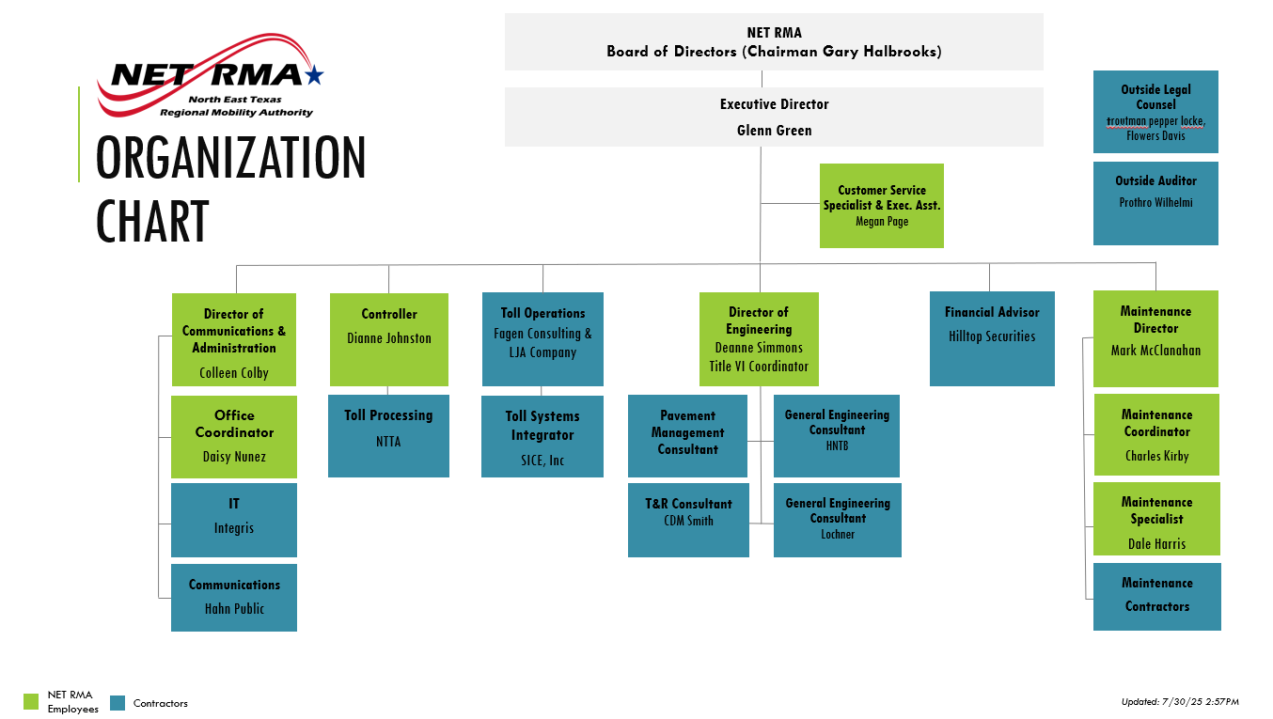

Attachment D

U.S. DOT Standard Title VI/Non-Discrimination Assurances

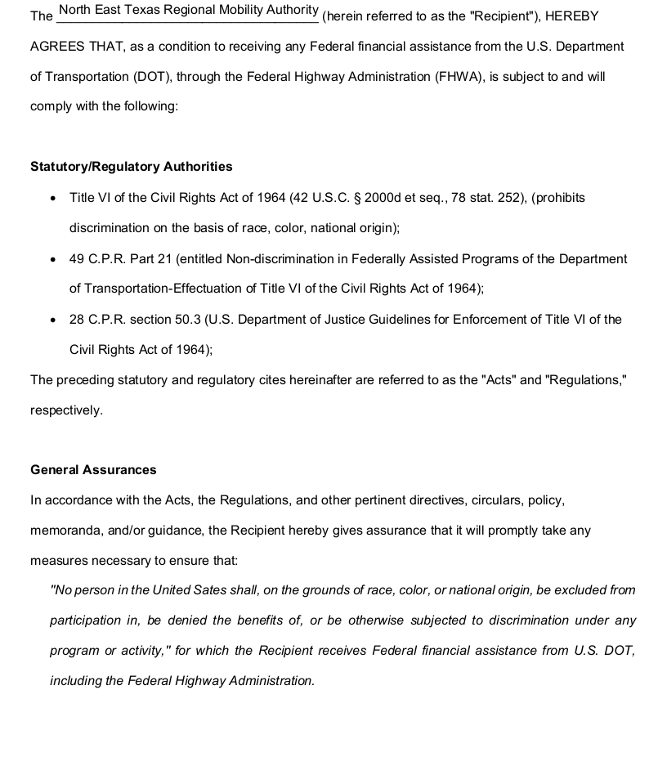

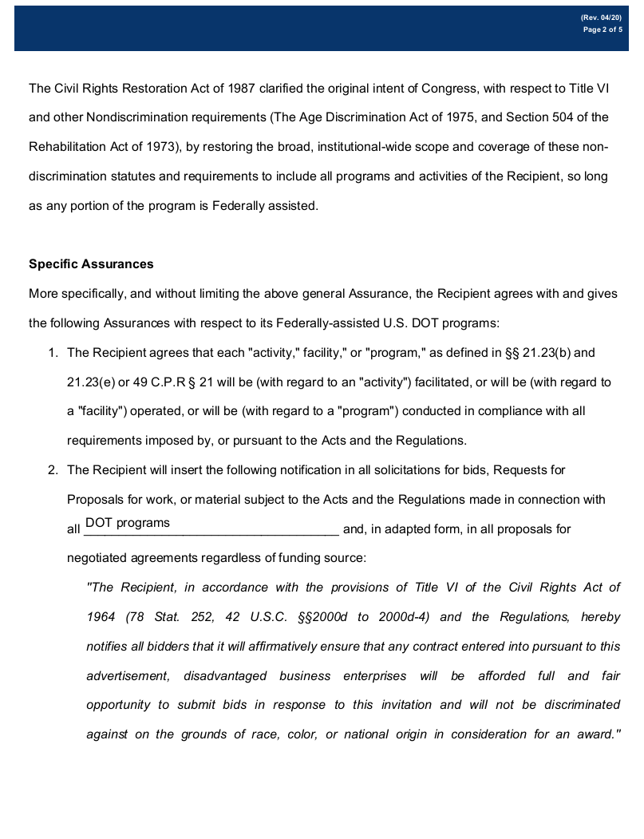

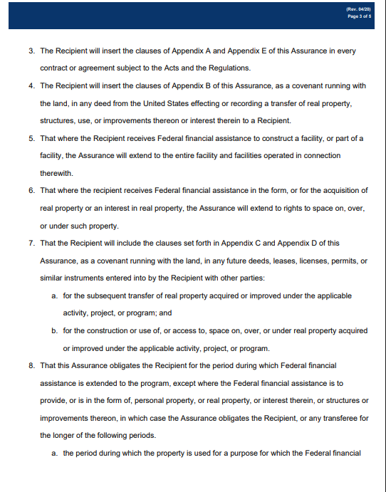

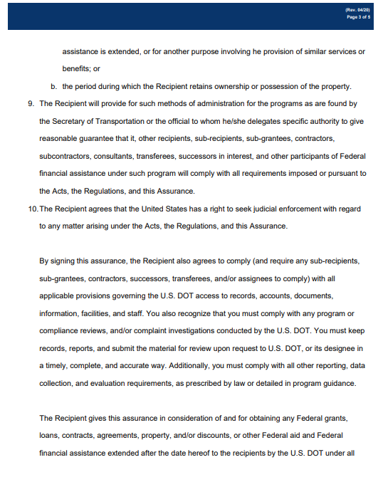

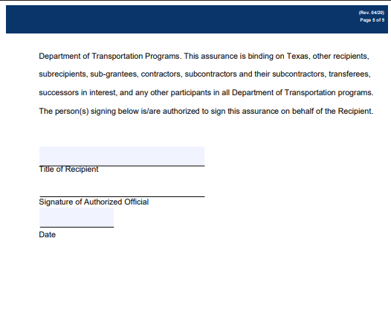

Attachment E
NET RMA Title VI Contractor Provisions

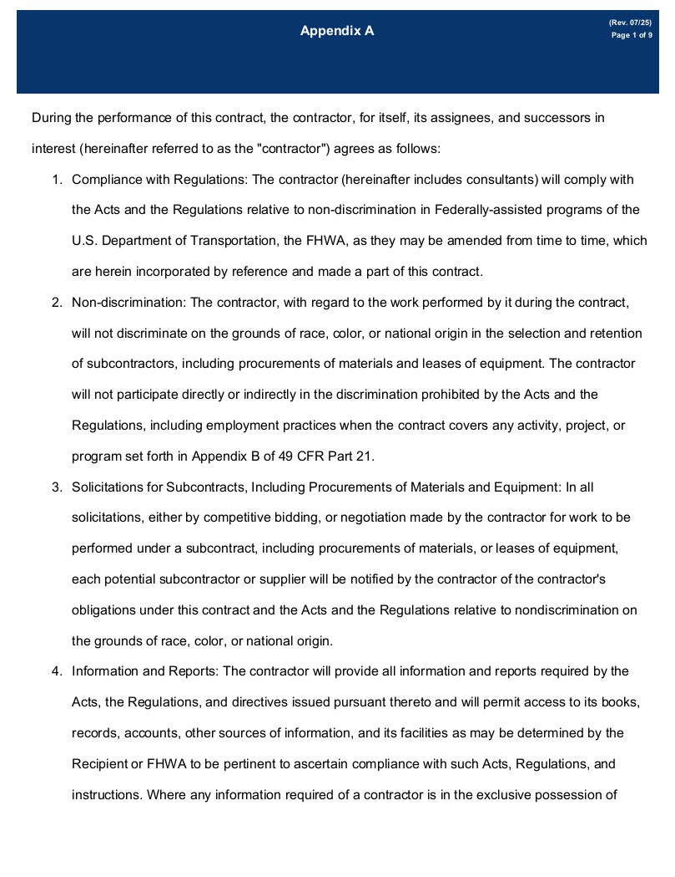

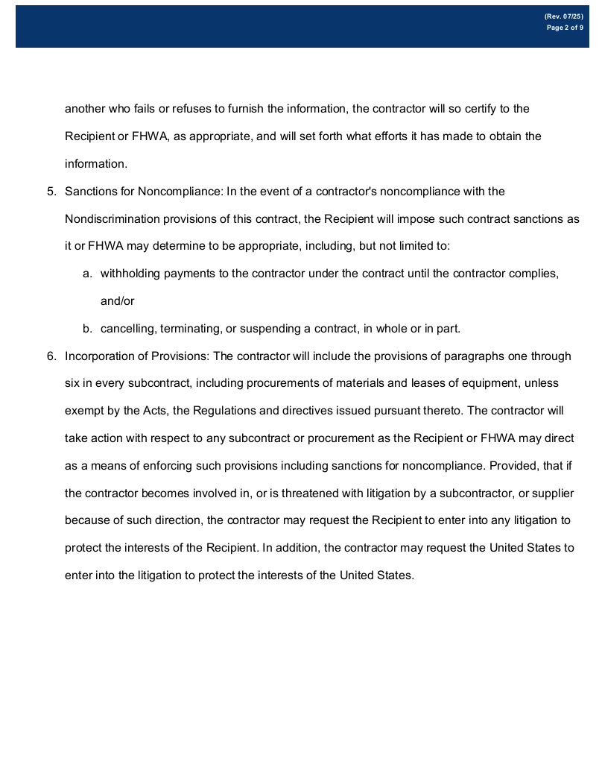

Attachment F
NET RMA Title VI Clauses for Deeds Transferring United States Property
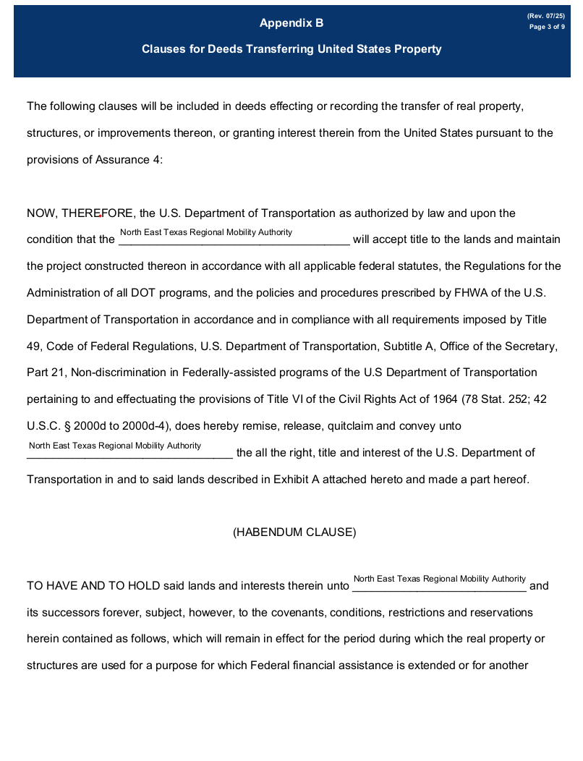
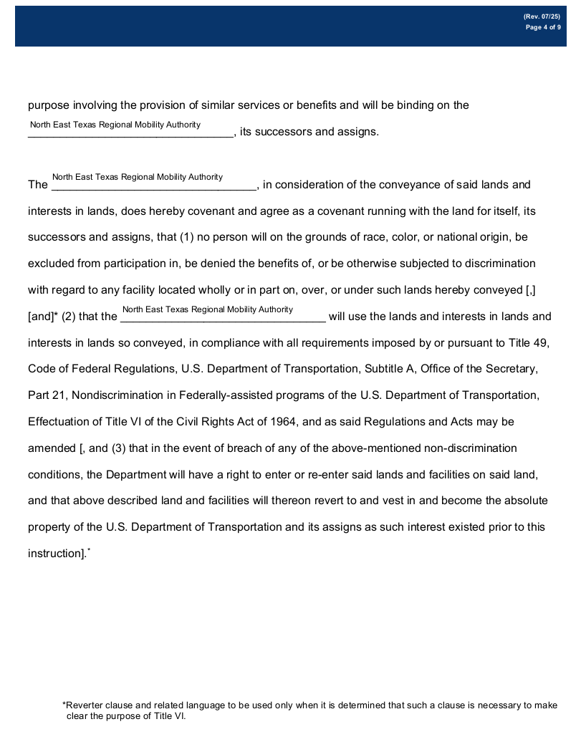

Attachment G
NET RMA Title VI Clauses for Real Property Acquired or Improved Under the Activity, Facility, or Program

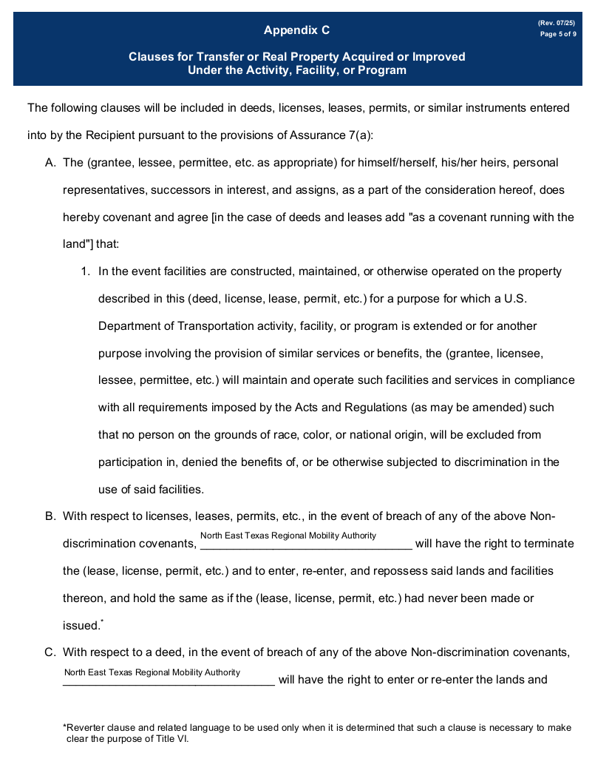

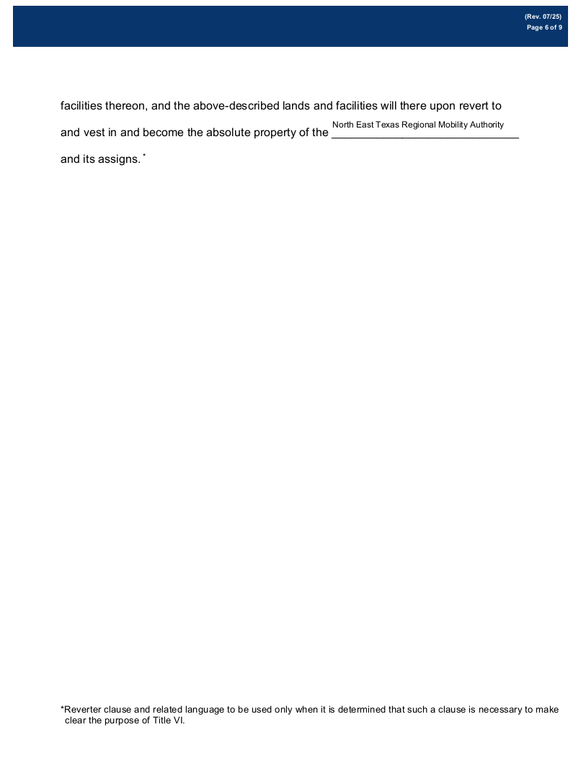

Attachment H
NET RMA Title VI Clauses for Construction/Use/Access to Real Property Acquired Under the Activity, Facility or Program

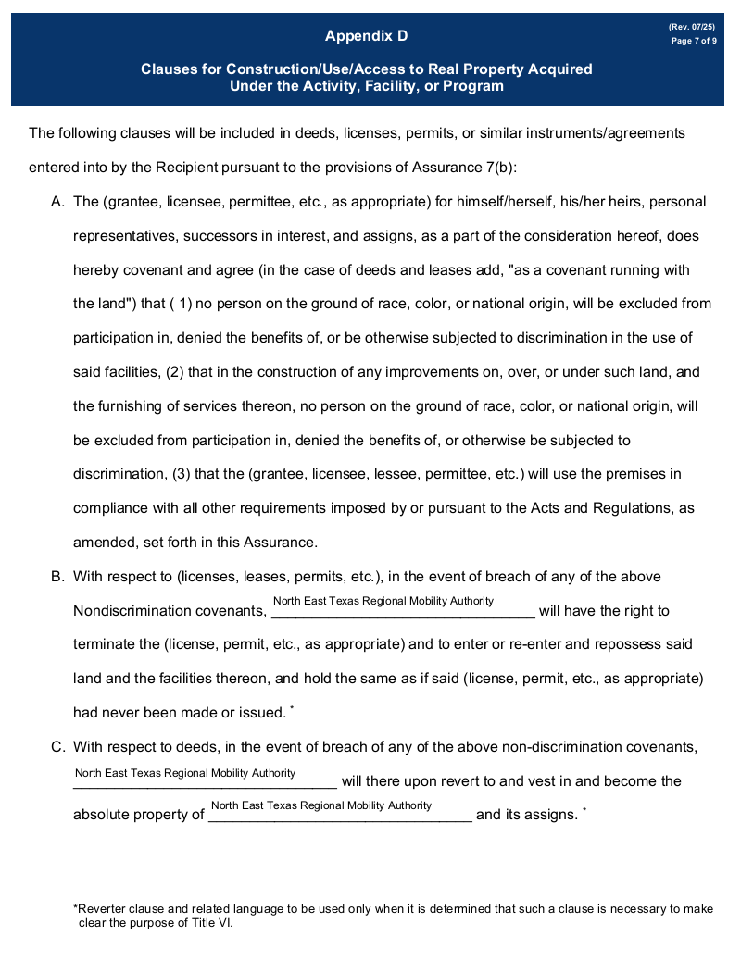

Attachment I
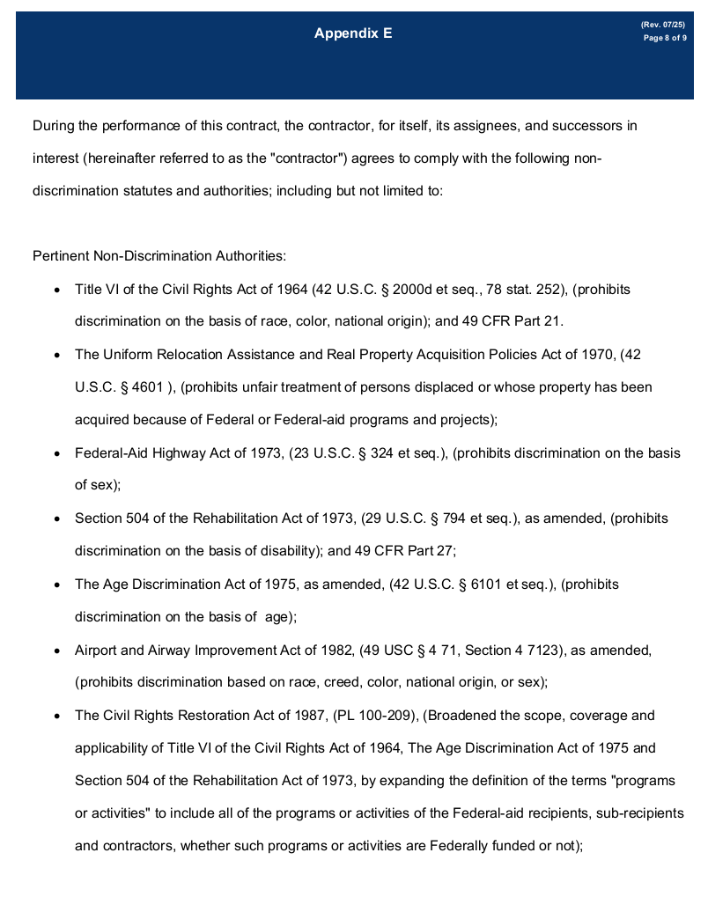
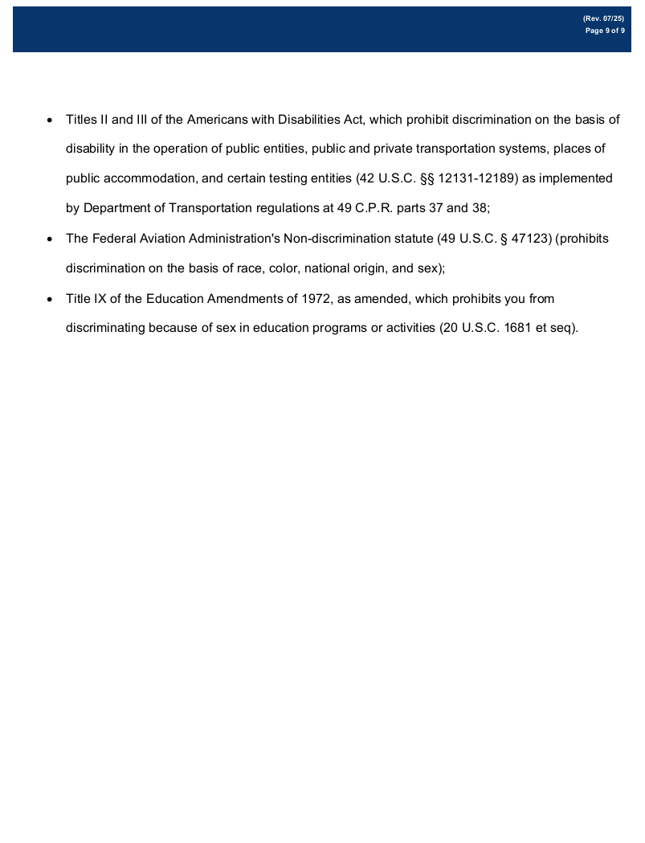

Attachment J
North East Texas Regional Mobility Authority
Title VI Complaint Process/Procedures

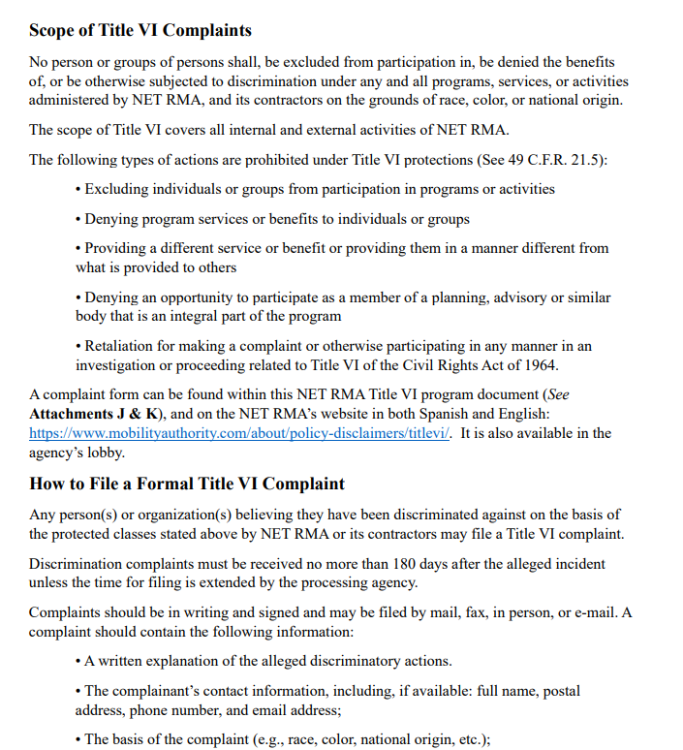

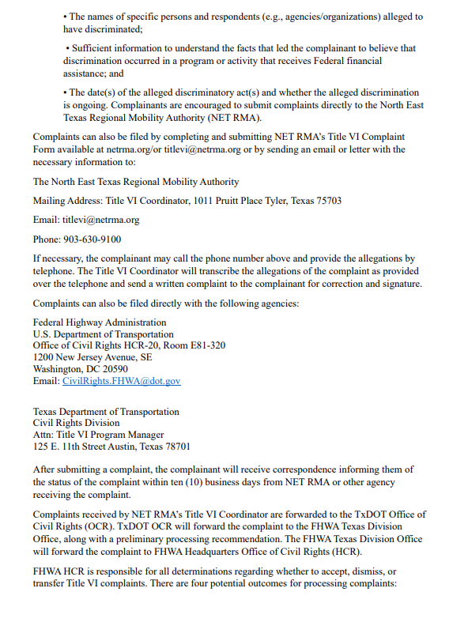

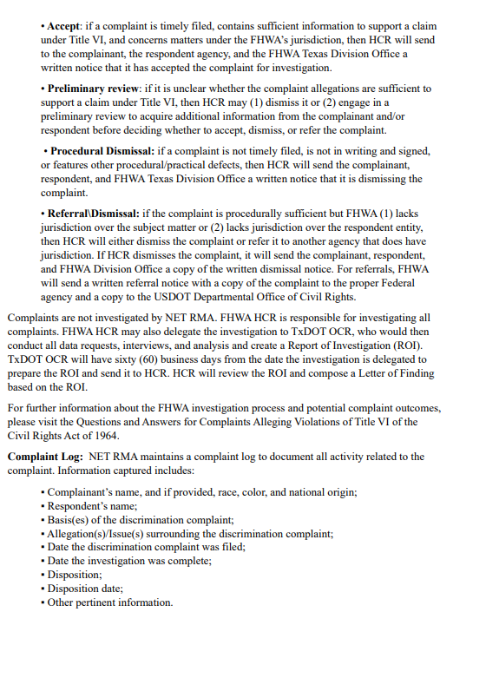

Attachment K

NET RMA Discrimination Complaint Form (English)
North East Texas Regional Mobility Authority
External Discrimination Complaint Form
Mail the completed and signed form to:
North East Texas Regional Mobility Authority
1011 Pruitt Place
Tyler, TX 75703

First Name:

Last Name:

Mailing Address – Including City, State, and Zip code:

Telephone:
Email:
Preferred Method Of Contact Telephone Email Other (Please Specify)

- Race ______________
- Color _____________
- Age _______________
- Gender ____________
- National Origin ______________________________
- Disability ___________________________________

Please indicate the basis of your complaint by checking one or more of the options listed

Date and place of alleged discriminatory action(s). Please indicate the earliest date of discrimination and the most recent date of discrimination.

How were you discriminated against? Please explain your complaint as clearly as possible. Include how other persons were treated differently. Use additional sheet(s), if necessary. Attach supporting documents if available.

The law prohibits intimidation or retaliation against anyone because they have either taken action, or participated in action, to secure rights protected by the laws. If you feel that you have been retaliated against, separate from the discrimination alleged above, please explain the circumstances below. Describe the action you took which you believe was the cause for the alleged retaliation.

Names of persons (witnesses, fellow employees, supervisors or others) whom we may contact for additional
information to support or clarify your complaint (attach additional pages, if necessary):
Name Address Telephone
1)
2)
3)
4)

What action(s) have you or your representative taken to attempt to resolve this complaint? Please include filing dates or other dates as applicable.
Action: Date:
- Filed with the Federal Highway Administration
- Filed with the U.S. Department of Transportation
- Filed with another Federal agency
- Filed in Federal Court
- Other action

Please provide any additional information you feel would be helpful in investigating this matter.

Briefly explain what remedy, or action, you are seeking for the alleged discrimination.

We cannot accept an unsigned complaint. Please sign and date the complaint form below.

________________________________________ ______________________
Signature Date

Attachment L

NET RMA Discrimination Complaint Form (Spanish)
North East Texas Regional Mobility Authority
Formulario de Quejas por Motivo de Discriminación
Envié el formulario completo a:
North East Texas Regional Mobility Authority
909 ESE Loop 323, Ste 520
Tyler, TX 75701

Nombre:

Apellido:

Dirección domiciliar (ciudad, estado, código postal):

Número de teléfono:

Correo Electrónico:

Método preferido de contacto: Teléfono Correo Electrónico Otro (especifique por favor)
- Raza ______________
- Color _____________
- Edad _______________
- Sexo ____________
- Origen Nacional ______________________________
- Impedimento ___________________________________

Por favor indica el motivo por hacer una queja.

Fecha aproximada del presunto acto de discriminación. Indique por favor la fecha más temprana de la discriminación y la fecha más reciente de la discriminación.

¿Cómo es que fue discriminado? Sírvase describir, en sus propias palabras, el acto de presunta discriminación. Relate lo que ocurrió y quién fue la persona responsable del acto y cómo trataron a otras personas diferentemente. Utilice las hojas adicionales, en caso de necesidad.

La ley prohíbe también la venganza contra cualquier persona para oponer la discriminación de la persona que tomo acción o a una persona participando en la investigación de una queja de discriminación. Si usted se siente que lo han amenazado, a parte de la discriminación alegada arriba, por favor explique las circunstancias abajo. Describa la acción que usted tomó.

Por favor escriba el nombre(s) e información de contacto para cualquier persona (testigos, empleados del compañero, supervisores, u otros) que podamos contactar para obtener información adicional y clarificar o justificar su alegación(es). Utilice las hojas adicionales, en caso de necesidad.
nombre dirección domiciliar número de teléfono
1)
2)
3)
4)

¿Qué acciones ha tomado usted o su representante para resolver esta queja? Incluya por favor las fechas de su representación u otras fechas que sean aplicables.
Action: Date:
- Administración Federal de Carreteras de los EE.UU
- Departamento de Transporte de los EE.UU.
- Otros Agencias Federales de los EE.UU.
- Tribunal Federal de los EE.UU.
- Otros

Favor de proporcionar cualquier información adicional y/o fotografías que sean pertinente a la investigación.

Explique que medidas o acción a tomado en el presunto acto de discriminación.

No podemos aceptar una queja sin firma. Favor de incluir su firma y la fecha a continuación:

________________________________________ ______________________
Firma del Demandante Fecha

We cannot accept an unsigned complaint. Please sign and date the complaint form below.

________________________________________ ______________________
Signature Date

Attachment M

“I-Speak” Language Identification Card

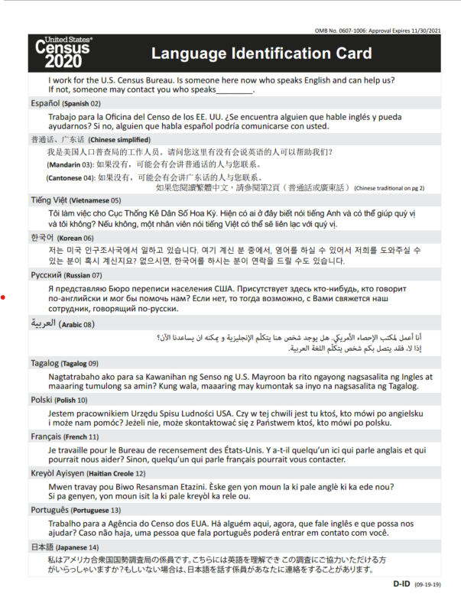

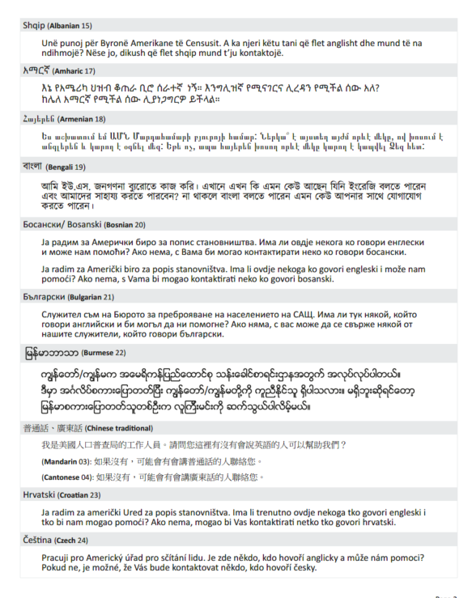

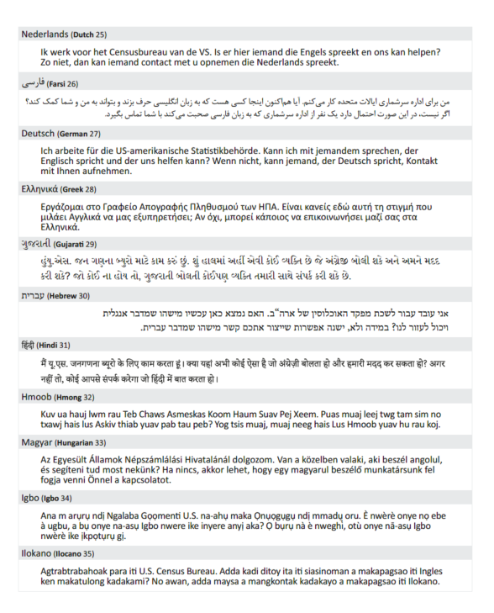

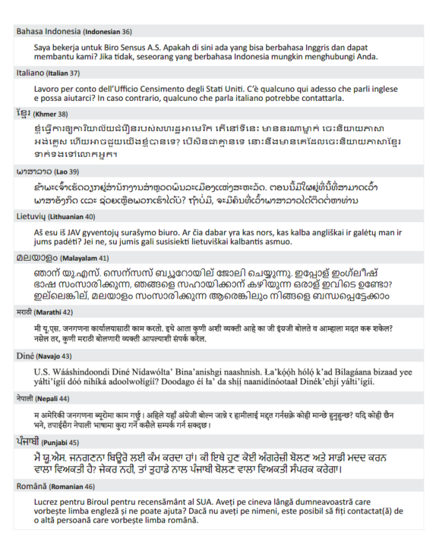

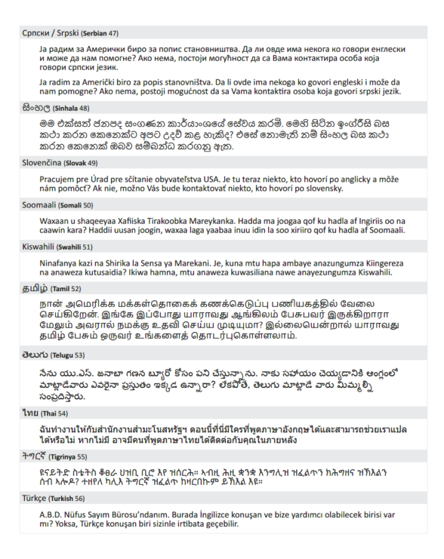

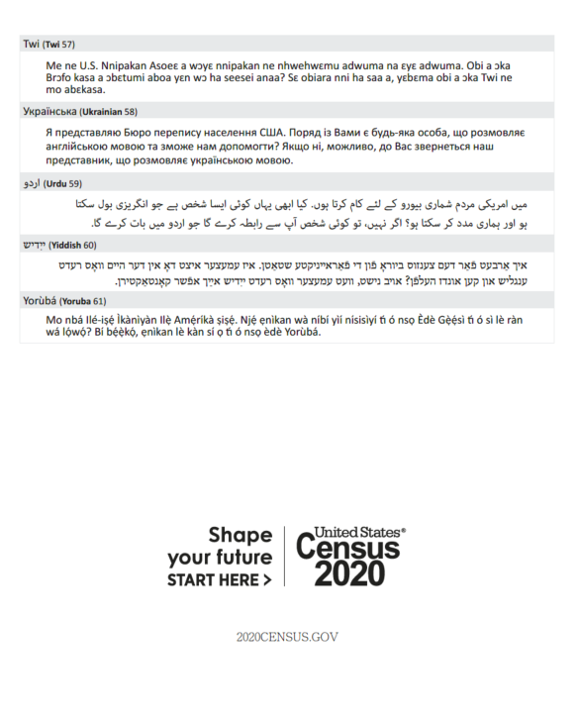

Attachment N

FHWA Form-1273

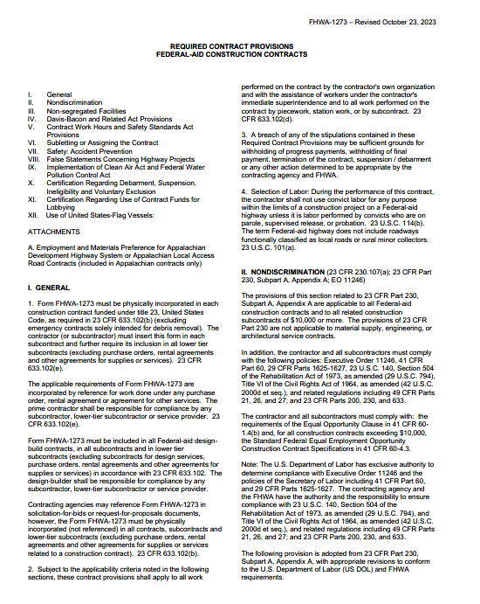

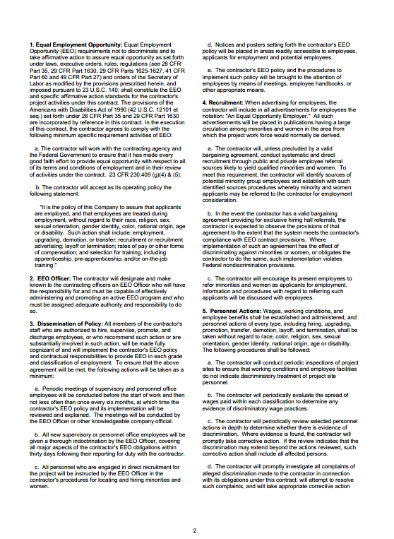

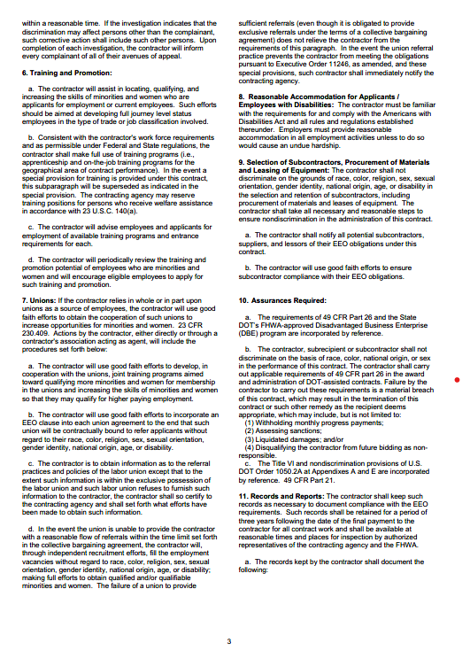

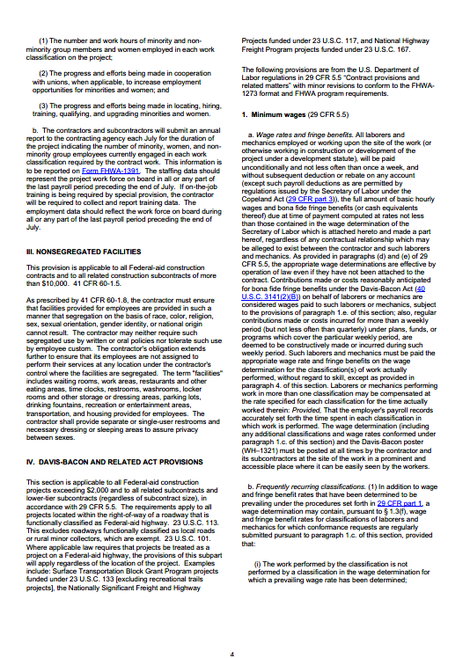

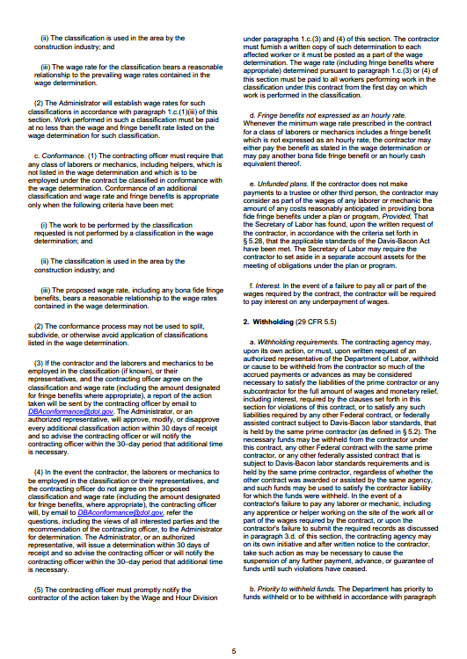

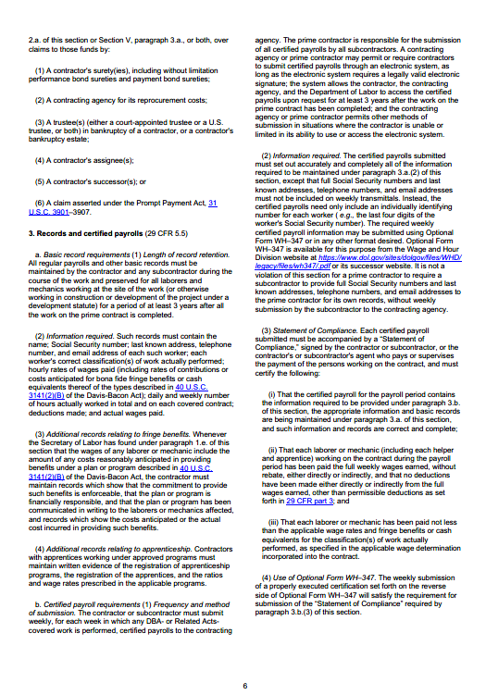

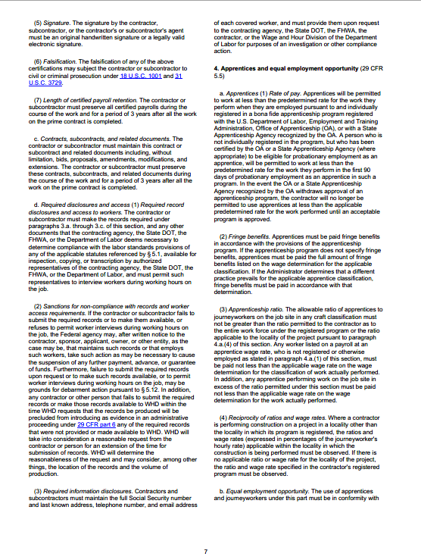

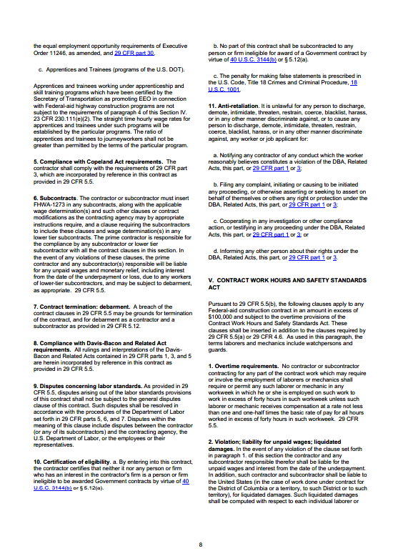

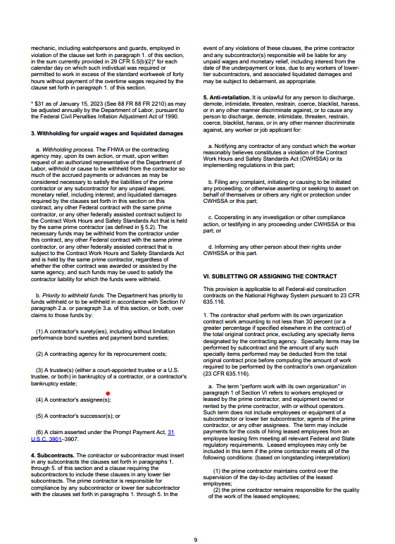

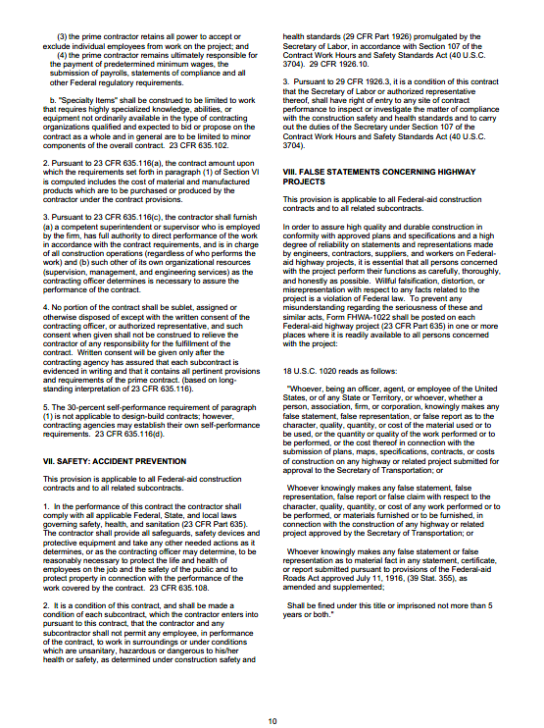

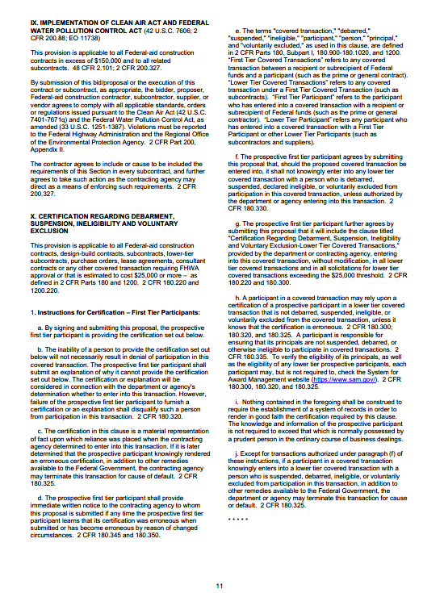

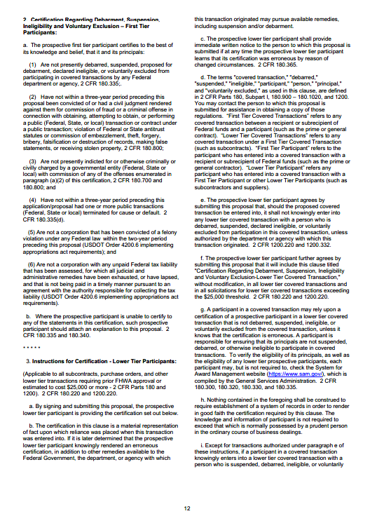

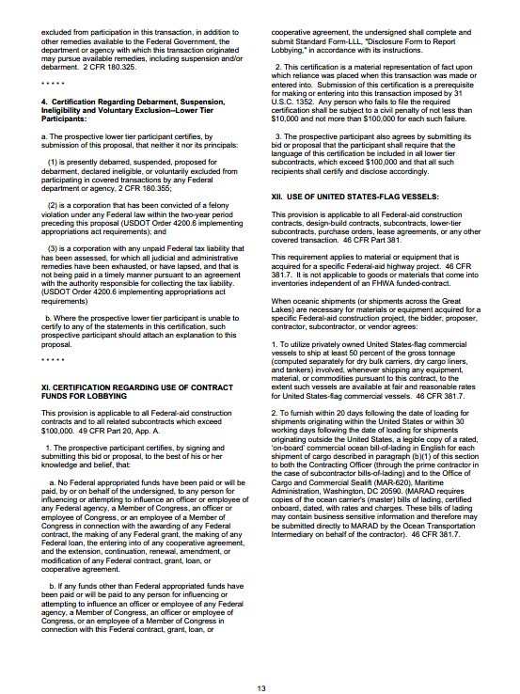

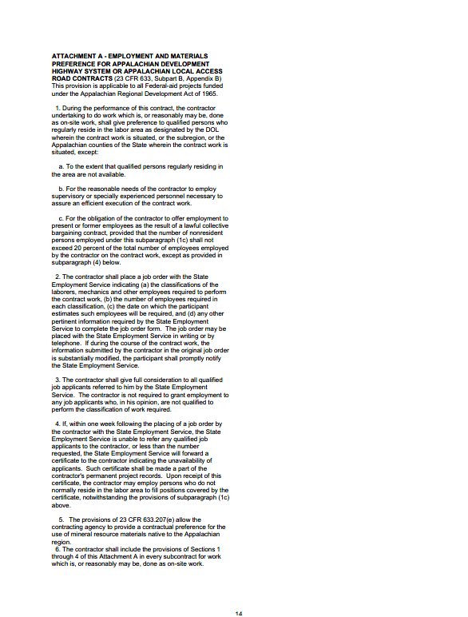

Attachment O

Sample Public Involvement Plan

